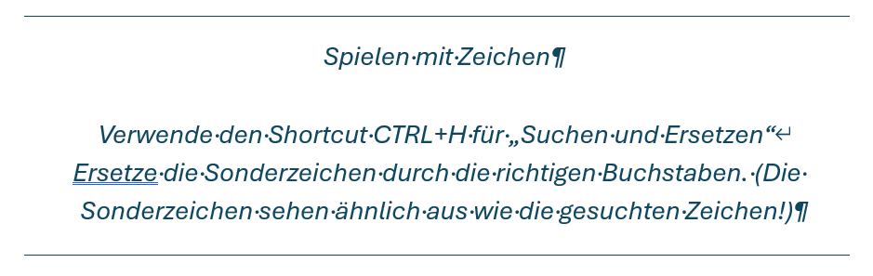
W€1t h1nt€n, h1nt€r d€n Wortb€rg€n, f€rn d€r Länd€r Vok@l1€n *nd Kon$on@nt1€n l€b€n d1€ Bl1ndt€xt€. @bg€$ch1€d€n wohn€n $1€ 1n B*ch$t@bh@*$€n @n d€r Kü$t€ d€$ $€m@nt1k, €1n€$ groß€n $pr@choz€@n$. €1n kl€1n€$ Bächl€1n n@m€n$ D*d€n fl1€ßt d*rch 1hr€n Ort *nd v€r$orgt $1€ m1t d€n nöt1g€n R€g€l1@l1€n. €$ 1$t €1n p@r@d1€$m@t1$ch€$ L@nd, 1n d€m €1n€m g€br@t€n€ $@tzt€1l€ 1n d€n M*nd fl1€g€n. N1cht €1nm@l von d€r @llmächt1g€n 1nt€rp*nkt1on w€rd€n d1€ Bl1ndt€xt€ b€h€rr$cht – €1n g€r@d€z* *northogr@ph1$ch€$ L€b€n. €1n€$ T@g€$ @b€r b€$chloß €1n€ kl€1n€ Z€1l€ Bl1ndt€xt, 1hr N@m€ w@r Lor€m 1p$*m, h1n@*$ z* g€h€n 1n d1€ w€1t€ Gr@mm@t1k. D€r groß€ Oxmox r1€t 1hr d@von @b, d@ €$ dort w1mm€l€ von bö$€n Komm@t@, w1ld€n Fr@g€z€1ch€n *nd h1nt€rhält1g€n $€m1kol1, doch d@$ Bl1ndt€xtch€n l1€ß $1ch n1cht b€1rr€n. €$ p@ckt€ $€1n€ $1€b€n V€r$@l1€n, $chob $1ch $€1n 1n1t1@l 1n d€n Gürt€l *nd m@cht€ $1ch @*f d€n W€g. @l$ €$ d1€ €r$t€n Hüg€l d€$ K*r$1vg€b1rg€$ €rklomm€n h@tt€, w@rf €$ €1n€n l€tzt€n Bl1ck z*rück @*f d1€ $kyl1n€ $€1n€r H€1m@t$t@dt B*ch$t@bh@*$€n, d1€ H€@dl1n€ von @lph@b€tdorf *nd d1€ $*bl1n€ $€1n€r €1g€n€n $tr@ß€, d€r Z€1l€ng@$$€. W€hmüt1g l1€f 1hm €1n€ rh€tor1$ch€ Fr@g€ üb€r d1€ W@ng€, d@nn $€tzt€ €$ $€1n€n W€g fort. *nt€rw€g$ tr@f €$ €1n€ Copy.

